Display_Name..
Computer Programming Using Kivy - OpenGL 4 - Resource Gathering
GOAL: Use an existing mesh file that is a complete scene, and set objects as items you can gather.

(You must first have a completed and working opengl1.py)
Update the 3D engine:
- Go to your home drive (File Explorer, Computer, T:\username or H:)
- Go to your opengl folder, then double-click update-kivyglops
Get a scene with items (or see bonus or and skip this section):
- Go to Resources R:\Meshes\Environments,Outdoor-Manmade\Medieval Kind of Seaport by tokabilitor (CC0)
[or go to expertmultimedia.com/resources, then click Meshes, Environments,Outdoor-Manmade, then download & open medseaport.zip]
- Ctrl A to select all
- Ctrl C to copy
- Go to your home drive (such as T:\username or H:)
- Open your opengl1 folder
- Ctrl V to paste

A dictionary contains named values. KivyGlops can use a dictionary to understand an item. After designing the item (what happens when you bump into it and when you use it), get the exact name of the item meshes then call the set_as_item method on each:
- Open Geany
- File, Open, your home drive (such as T:\username or H:), opengl, opengl1.py (or opengl3.py)
- File, Save As, go to your opengl folder, then name this file opengl4.py
- Add the following to your load_glops method (if you keep your existing walkmesh code, change get_similar_names to look for “walkmesh” instead of “floor” and change old code so only medseaport1b and not previous scene is loaded):
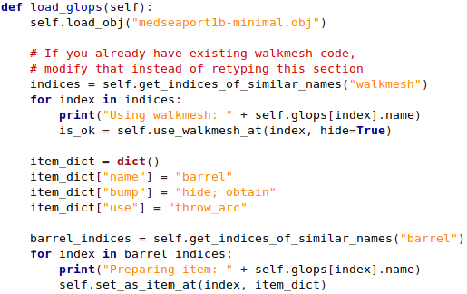
BONUS: Make or find your own scene, and set at least one object that you can pick up (open obj file in notepad++: to see ‘o’ names). Put obj, mtl, & any image files in opengl folder.

